**PERSON SPECIFICATION**

**Job Title: NDR Manager**

|  |  |  |
| --- | --- | --- |
|  | Essential | Desirable |
| **Qualifications & Experience** | IRRV Technician or equivalent work based experience  Minimum GCSE Maths & English or equivalent  Experience managing Revenues Team to achieve Service Plan outcomes.  Relevant management experience.  Experience in selection interviews for internal and external vacancies. | Trained in the use of Revenues & Benefits Capita processing and Civica Document Imaging systems. |
| **Knowledge** | In depth knowledge of Non-Domestic Rates & Business Improvement Districts legislation, guidance and case law.  An in depth knowledge of the relevant procedures and processes.  Extensive knowledge & experience of software. | Knowledge of Non-Domestic Rates & Business Improvement Districts legislation.  Awareness of Local Authority procedures. |
| **Skills** | Ability to work on own initiative, to be proactive and to react to service delivery.  Ability to prioritise workload effectively under pressure and meet deadlines and targets.  Ability and experience to manage employees and resources to achieve Service Plan.  High level of numeracy and literacy.  Ability to work under pressure and be flexible.  Ability to work constructively with other departments, ability to manage complex cases, to understand and react to Service delivery.  Ability to identify innovative approaches to service delivery  Ability to identify trends and make appropriate practical adjustments / recommendations  Excellent presentation, interpersonal and written skills. | Competent in all aspects of staff development, performance reviews, employee relations and training |
| **Delivering excellent Customer Service** | Demonstrate experience or understanding of customer care. Demonstrate ability to deal with customer enquiries in an appropriate, diplomatic and professional manner. |  |
| **Health, Safety and Welfare** | Able to demonstrate good general understanding of Health, Safety and Welfare policies and procedures  Demonstrate ability to achieve a good work life balance for self and for team |  |
| **Striving for Continuous Improvement** | Commitment to a learning culture  Able to give examples of flexible and positive response to change  Willingness to learn and to improve | Evidence of continued learning. |
| **Diversity and Equality** | Ability to understand the concept of diversity and respect for others and be committed to these issues | Able to promote fair treatment and equality of opportunity in both employment and service delivery. |
| **Communicating effectively** | Effectively communicates relevant information to others  Able to respond to varying levels of understanding from customers |  |
| **Attitude** | To demonstrate a positive attitude and promote and adhere to the workplace values of our organisations. |  |
| **Other special requirements** | Able to travel, as required, across the partnership*.*  Occasional need to work outside office hours. |  |

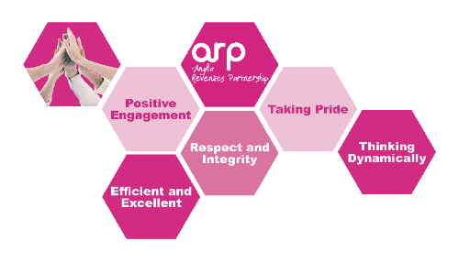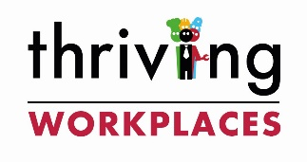

**ARP Awarded WellBeing Charter – July 2021**